Dear Patient

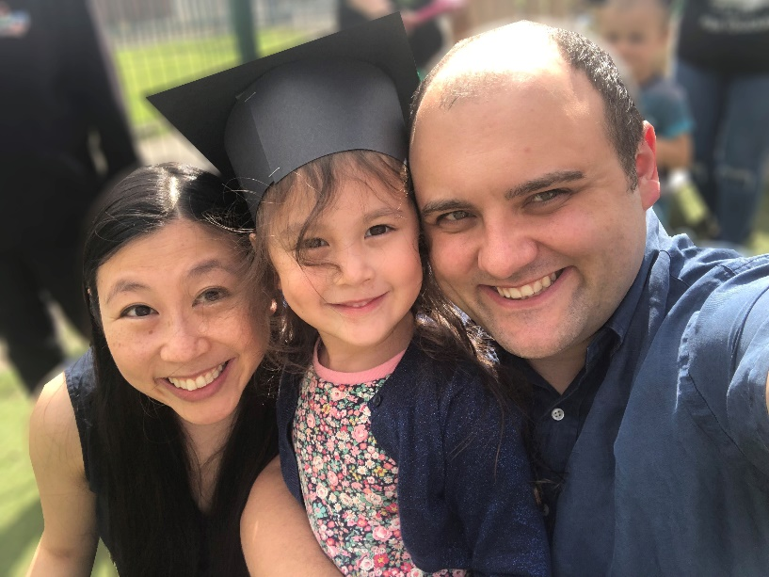
I would like to take this opportunity to introduce myself as the new owner of Sedgefield Dental. It is a privilege to take over from Dr Edmonds and I hope to continue, and build upon, his ethos of providing first class patient care.
I was born and raised in County Durham and returned in 2014 when I took over Kingsgate Dental in Durham city. I live in Durham with my wife, Katy, our two young children and dog. Running around after a four year old and a baby doesn’t leave much time for any other hobbies! Like Dr Edmonds and Adele, we are very much a family business and Katy helps a lot behind the scenes!
I Intend to split my time between Durham and Sedgefield. The main focus of my clinical work at Sedgefield will be to provide dental implants in house.
We plan to invest in new equipment and offer additional treatments to improve on the already excellent level of dental care. The team and I (old and new) are incredibly excited about the future of the practice. We are delighted that Jackie and Sarah are both staying on with us, so you will see some familiar faces at your next appointment. I would also like to introduce the new members of the core clinical team.

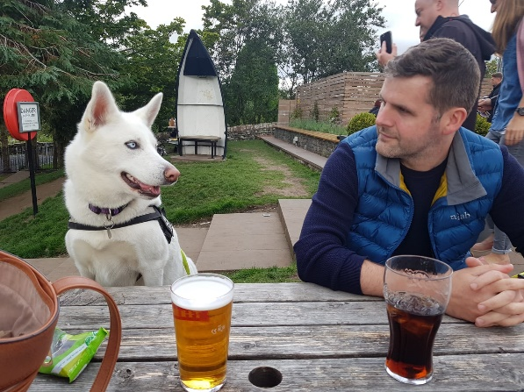
Dr Dave Redpath – Dentist
Also born in County Durham, Dave is a highly experienced dentist. Prior to becoming a dentist, he was an aircraft engineer in the RAF! He lives with his fiancé and has a husky named Nala. Outside of work he enjoys hiking, paddleboarding and cycling.
He will take over the every day dental care at the practice from Dr Edmonds. I have known Dave since we graduated from Newcastle University and have total confidence in his ability to deliver dentistry of the highest quality with great patient care.

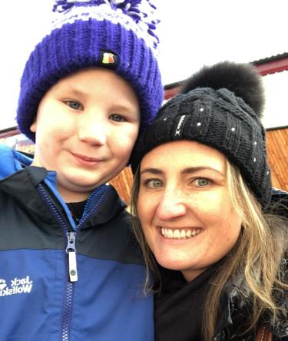
Charlotte Stephenson - Hygienist
We are introducing a dental hygienist as a new role into the practice. All adult plan members will now be offered dedicated hygiene appointments with Charlotte as part of their existing Practice Plan package.
Charlotte has been in the dental industry for over 22 years, 15 of which as a dental hygienist. She has a wealth of knowledge on oral care and hygiene. Charlotte also works with me at Kingsgate Dental so I know how dedicated she is to improving the oral health of her patients.
She lives near Sedgefield with her partner and young son. She enjoys reading, running and spending time with her family.

We all look forward to seeing you at your next appointment.

Should you have any queries about the changes or anything else about your plan, please do not hesitate to contact the practice on 01740 621040.

Yours Sincerely

Dr David Lamb

